Creating Main.tf file (New file created named main with terraform tf)

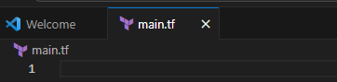

Creating 3 S3 Buckets

Bucket1 – AdventureTech

provider "aws" {

region = "us-east-1"

}

resource "aws_s3_bucket" "AdventureTech" {

bucket = "Adventure-MA-Bucket" #

}

resource "aws_s3_bucket" "NatureEscape" {

bucket = "NatureEscape-MA-Bucket" #

}

resource "aws_s3_bucket" "DataSummit" {

bucket = "DataSummit-MA-Bucket" #

a

}